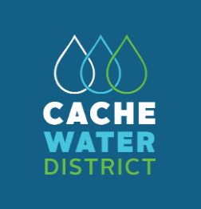
Our Water. Our Future. Our Choice.
The purposes of the District include planning for and facilitating the long-term conservation, development, protection, distribution, management, and stabilization of water rights and water supplies for domestic, irrigation, power, manufacturing, municipal, recreational, and other beneficial uses, including the natural stream environment, in a cost-effective way to meet the needs of the residents and growing population of Cache County.
www.cachewaterdistrict.com
_________________________________________________________________________________________________________

CACHE WATER DISTRICT BOARD OF TRUSTEES
MEETING MINUTES
May 1, 2023
The Cache Water District Board of Trustees convened for a regular meeting on May 1, 2023, at 5:30 p.m.
in the Cache County Historic Courthouse Council Chambers,199 North Main Street, Logan, Utah.

MEMBERS OF THE BOARD IN ATTENDANCE:

Mark Anderson – Logan #3 Council District
Jonathan Hardman – South Council District
Beth Neilson – Southeast Council District
Jeff Ostermiller - Logan #2 Council District
Max Pierce – North Council District
Bret Randall – Northeast Council District
Brett Roper – At Large Position
Jeannie Simmonds – Logan #1 Council District
Regan Wheeler – Agricultural Representative

MEMBERS OF THE BOARD EXCUSED:

Jared Clawson – At-Large Position
Kirt Lindley – At-Large Position

ATTENDANCE:

Nathan Daugs, Chris Slater, Chad Brown, Wayne Wurtsbaugh, Kelly Kopp

CALL TO ORDER

Chairman Pierce called the meeting to order at 5:30 p.m.

The May 1, 2023 meeting agenda and the minutes from April 3, 2023, were approved.

ACTION: Motion by Mr. Hardman to approve the agenda and the minutes as submitted. Seconded by Mr. Anderson. The motion was approved unanimously
(8-0).

Yea: Anderson, Hardman, Neilson, Ostermiller, Pierce, Randall, Roper, Wheeler

PUBLIC COMMENT

Chad Brown asked about the Bear River Water Rights meeting and what the latest information is and what CWD’s stand is. Mr. Daugs said Cache County Council submitted a letter last week, after their Council meeting, against the proposal. He is meeting with the local legislatures and the County Council in two weeks for further discussion. The State Engineer has not closed the comment period yet. CWD has not submitted a letter or taken a final position yet. Mr. Daugs will keep the Board and the public advised. The comments that have been submitted are online and can be reviewed at the State Division of Water Rights.

Ms. Simmonds arrived at 5:51 p.m.

FINANCIAL REPORT

See -Attachment 1-

CALENDAR EVENTS

- May 7 – CWD Board Workshop Discussion 2:00-6:00 p.m. @ USU Water Lab
- May 10 - 1:30 Utah Water Task Force
    - May 19 - Ag Optimization @ 10:00 a.m.
    - May 15 - APO - 5:30 Secondary Water; 6:00 Cloud Seeding/Snotel
    - May 18 - District Tour @ 1:00 p.m.
    - May 25 - Bear River Commission Tour
    - May 25 - Localscapes Class 6:00-8:00 p.m.
    - June 9 - Ag Water Optimization @ 1:30 p.m.
    - June 19 - APO - 5:30 Local outreach 6:00 Conservation

MANAGER’S REPORT

PL-566 PROJECT UPDATES

Logan River – The paperwork has been received, the official contract for $1.2 million has been signed and the project is ready to move forward. JUB is working with NRCS for the public noticing for public comments. Mr. Daugs has been assured that the link will be updated and working before the public comment period begins.

Wellsville/Mendon – NRCS is waiting for funds to be submitted from the State, after which the contract will be signed.

Porcupine – Has been sent to the contractor to begin the Preliminary Investigative Feasibility Report (PIFR) process.

APO REPORTS – LOCAL OUTREACH & WATER PURCHASING

See -Attachment 2-

CURTIS CREEK DAM

See -Attachment 3-

WATER CHECK PROGRAM – KELLY KOPP

See -Attachment 4-

ADJOURN

The meeting adjourned at 7:10 p.m.

-Attachment 1-
3:21 PM Cache Water District

_{05/01/23} Profit & Loss Budget vs. Actual

Accrual Basis January through March 2023

Jan - Mar 23 Budget % of Budget

Ordinary Income/Expense Income
Cache County Property Taxes | 236,137.31 |  | 275,000.00 |  | 85.9%
PL-566 Watershed Grant | 65,000.00 |  | 700,000.00 |  | 9.3%
Restricted Income  Northern Utah Water Conference | 800.00 |  | 0.00 |  | 100.0%
Restricted Income - Other | 7,500.00 |  | 153,000.00 |  | 4.9%
Total Restricted Income | 8,300.00 |  | 153,000.00 |  | 5.4%
Wellsville Mendon Study | 104,141.53 |  | 800,000.00 |  | 13.0%
Total Income | 413,578.84 |  | 1,928,000.00 |  | 21.5%
Gross Profit | 413,578.84 |  | 1,928,000.00 |  | 21.5%
Expense  Office  Bank Charges | 70.00 |  | 0.00 |  | 100.0%
Insurance and Bonding | 0.00 |  | 5,000.00 |  | 0.0%
Office Supplies | 347.64 |  | 2,000.00 |  | 17.4%
Publications | 0.00 |  | 4,500.00 |  | 0.0%
Rent Technology  Cell Phone | 0.00  213.17 |  | 5,500.00  0.00 |  | 0.0%  100.0%
Computer and printer | 45.02 |  | 0.00 |  | 100.0%
Technology - Other | 0.00 |  | 3,000.00 |  | 0.0%
Total Technology | 258.19 |  | 3,000.00 |  | 8.6%
Vehicle  Fuel | 0.00 |  | 2,500.00 |  | 0.0%
Vehicle - Other | 0.00 |  | 50,000.00 |  | 0.0%
Total Vehicle | 0.00 |  | 52,500.00 |  | 0.0%
Total Office | 675.83 |  | 72,500.00 |  | 0.9%
Outreach  Conservation | 0.00 |  | 30,000.00 |  | 0.0%
Dues | 666.00 |  | 2,500.00 |  | 26.6%
Lobbyist | 0.00 |  | 10,000.00 |  | 0.0%
Northern Utah Water Conference | 725.00 |  | 0.00 |  | 100.0%
Sponsorships | 200.00 |  | 2,750.00 |  | 7.3%
Training | 1,119.46 |  | 6,000.00 |  | 18.7%
Website | 0.00 |  | 2,000.00 |  | 0.0%
Total Outreach | 2,710.46 |  | 53,250.00 |  | 5.1%
Personnel  Salary and benefits | 30,823.46 |  | 150,000.00 |  | 20.5%
Travel and Mileage | 1,709.78 |  | 5,000.00 |  | 34.2%
Workers Compensation | 3,073.28 |  | 0.00 |  | 100.0%
Total Personnel | 35,606.52 |  | 155,000.00 |  | 23.0%
Professional Fees Administrative | 0.00 |  | 1,500.00 |  | 0.0%
Attorney Services | 0.00 |  | 30,000.00 |  | 0.0%
Audit | 0.00 |  | 7,000.00 |  | 0.0%
Financial Services | 346.00 |  | 10,000.00 |  | 3.5%
Total Professional Fees | 346.00 |  | 48,500.00 |  | 0.7%
Project funding  Bear River Development | 35,910.00 |  | 150,000.00 |  | 23.9%
Cloud Seeding | 40,991.75 |  | 63,000.00 |  | 65.1%
Logan Observatory | 0.00 |  | 5,000.00 |  | 0.0%
Water Acquisition | 0.00 |  | 20,000.00 |  | 0.0%

3:21 PM Cache Water District

_{05/01/23} Profit & Loss Budget vs. Actual

Accrual Basis January through March 2023

Jan - Mar 23 Budget % of Budget

Water Studies
PL566 Logan River | 65,000.00 |  | 700,000.00 |  | 9.3%
Water Master Plan | 0.00 |  | 0.00 |  | 0.0%
Wellsville/Mendon Irrigation | 8,205.95 |  | 800,000.00 |  | 1.0%
Water Studies - Other | 951.79 |  | 120,000.00 |  | 0.8%
Total Water Studies | 74,157.74 |  | 1,620,000.00 |  | 4.6%
Total Project funding | 151,059.49 |  | 1,858,000.00 |  | 8.1%
Total Expense | 190,398.30 |  | 2,187,250.00 |  | 8.7%
Net Ordinary Income | 223,180.54 |  | -259,250.00 |  | -86.1%
Net Income | 223,180.54 |  | -259,250.00 |  | -86.1%

-Attachment 2-
LOCAL OUTREACH APO – April 18, 2021

Attendance: Max Pierce, Jon Hardman, Jeannie Simmonds, Scott Clark, Nate Daugs

- Jon said Mendon Mayor Buist asked if CWD wanted to meet with the Mayor’s Association in September.

- Nate fielded a call from Cache Valley Daily questioning secondary metering.

- Outreach has included: The Home & Garden Show, Utah Water Users Conference, Fall Conference, Summer Water Checks and doing a tour in a few weeks.

- Jon said we need to take a good look at Slow the Flow. Nate said we may phase out after the current contract. Jon asked if they have indicated any interest in targeting Cache County. Nate said they consider it broadly (statewide) however, campaigns like billboards do not help with Cache Valley.

- The “flip your strip” program is still being worked out. Jon asked if it should be promoted through CWD. Nate suggested working with cities about getting the word out.

- Nate said the new website platform has a link to set up for water alerts/notices; people can sign up for notifications through phone or email. The new site will be reviewed at the May meeting.

- Summer audits – have funds from last year that can be used to hire more people if necessary. Would like to have 2-3 teams to work through the summer.

- The outreach program continues to grow, members feel pleased with what is happening at this point. Nate says more people are reaching out with questions.

- Briefly discussed possibility of District helping with secondary metering. What role could be and future growth.

- Talked about the logistics for upcoming tour sites.

APO: WATER PURCHASING – April 17, 2023

Chair: Jeannie Simmonds

Attendance: Jeannie Simmonds, Brett Roper, Beth Neilson, Jeff Ostermiller,
Nate Daugs

- Discussed when/if/how the District should/will acquire water rights – what opportunities/direction should be explored. The current budget will not allow for it, but it needs to be considered.

- Discussed the understanding of why water districts may purchase water rights. Nate explained that Weber Basin needed someone local to manage resources, over time they have purchased more as they have grown. It creates a centralized system. Beth asked if the objective is to purchase rights to control the water and whether a publicly-elected entity should do so. Water will not be taken away, smaller cities/canal companies may want help in the future. One of the goals of CWD is to preserve and protect local water, buying shares might seem reasonable for someone who wanted to sell/purchase shares. Nate explained that this is a long time in the future, however, if canal companies ever need to liquidate shares and/or help operate their systems, it might be smart for CWD to acquire them over time.

- It makes sense that as canal companies grow, the District could help provide services and manage/maintain canals better. Jeannie noted that the aging management system should be considered and this might be a role where CWD could help.

- Jeannie would like to have a line item in the budget for future consideration. Nate said more discussion about this can be had at the May 3 Board Workshop. Consideration will need to be that this would require a tax increase and need more personnel to implement; it will be important to discuss future needs and when/where growth should be focused.

-Attachment 3-

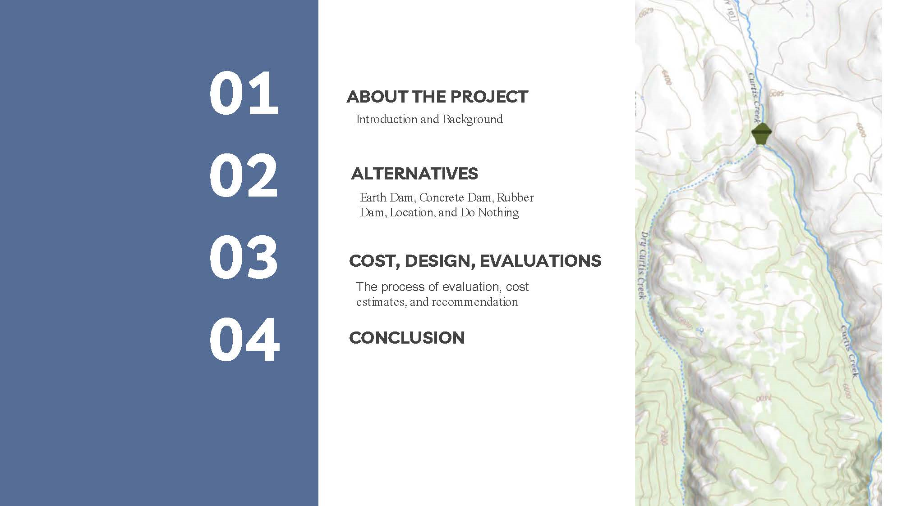

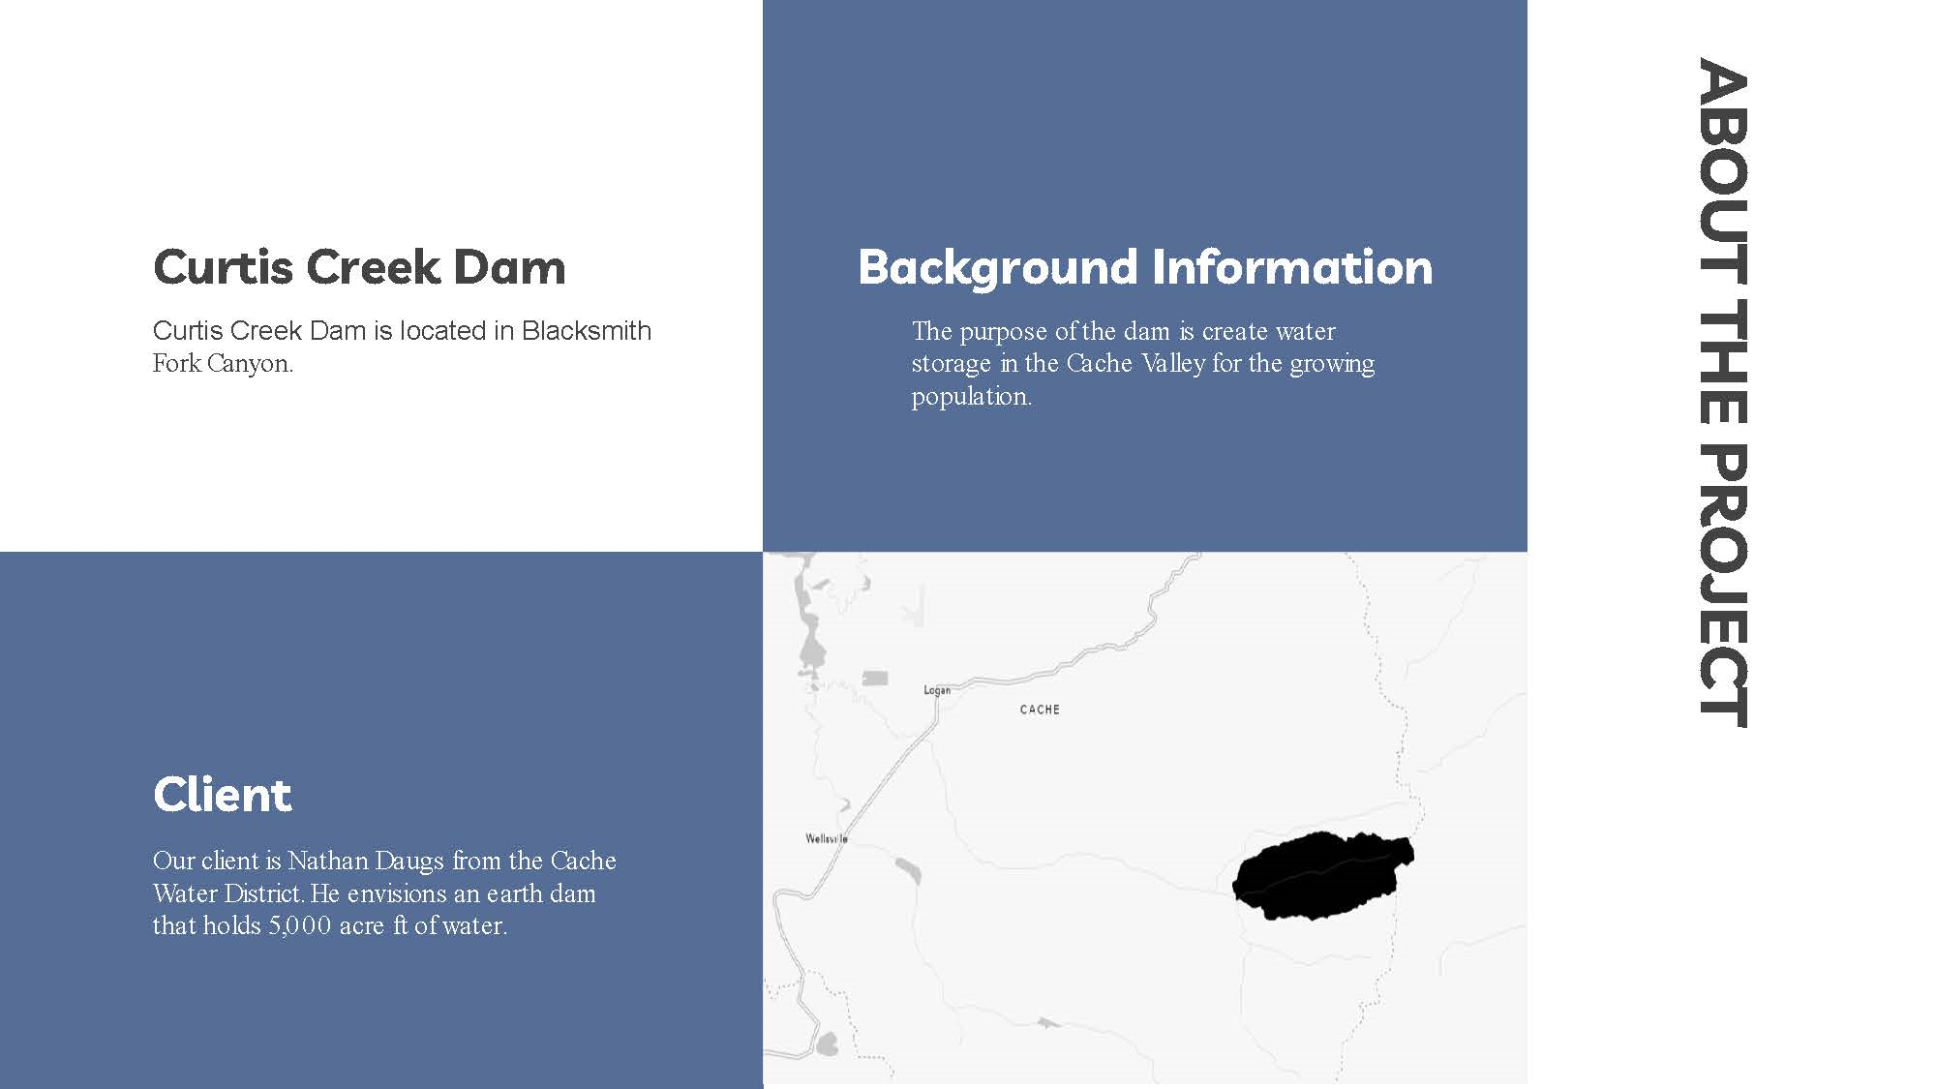

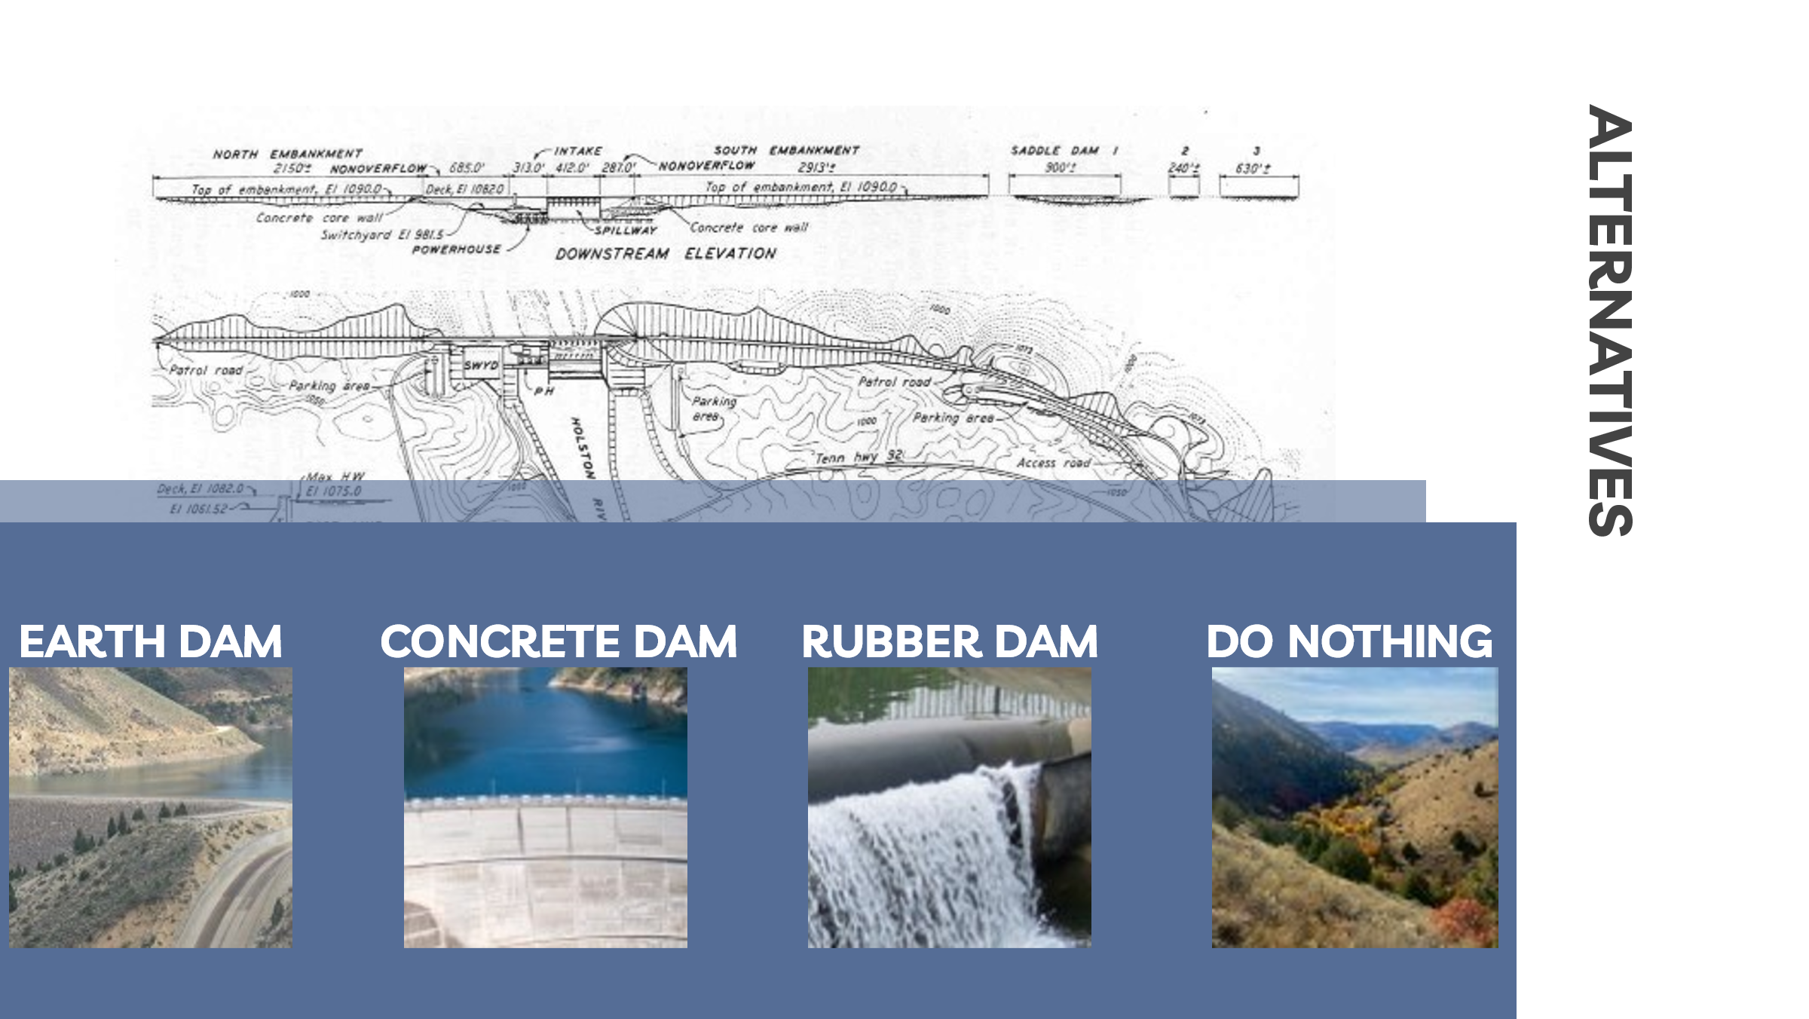
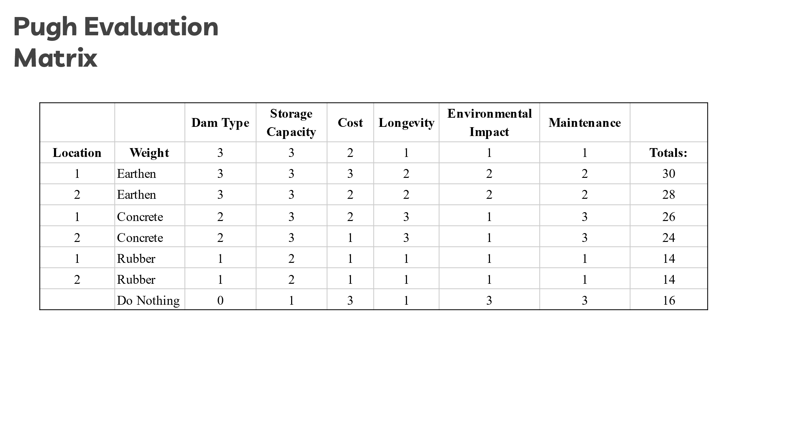

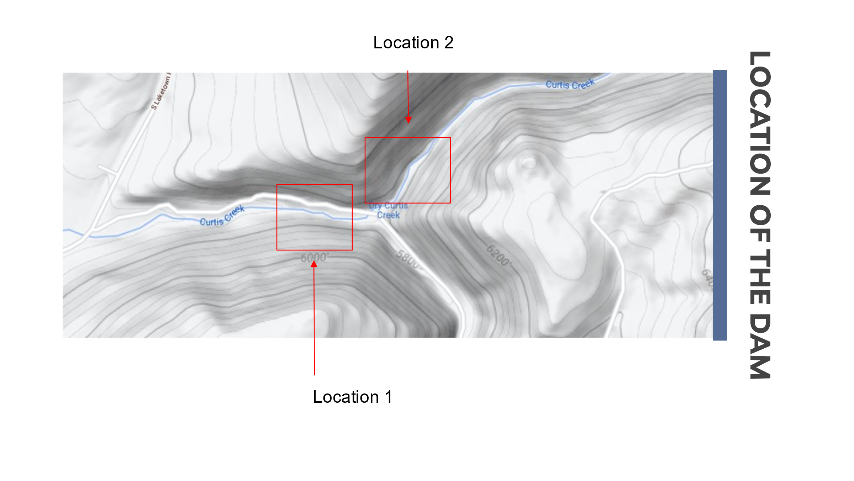
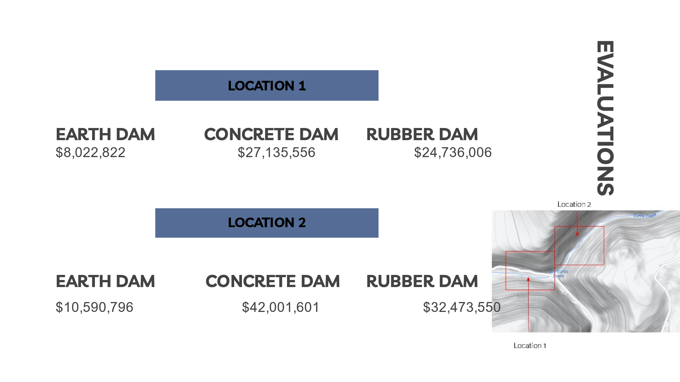
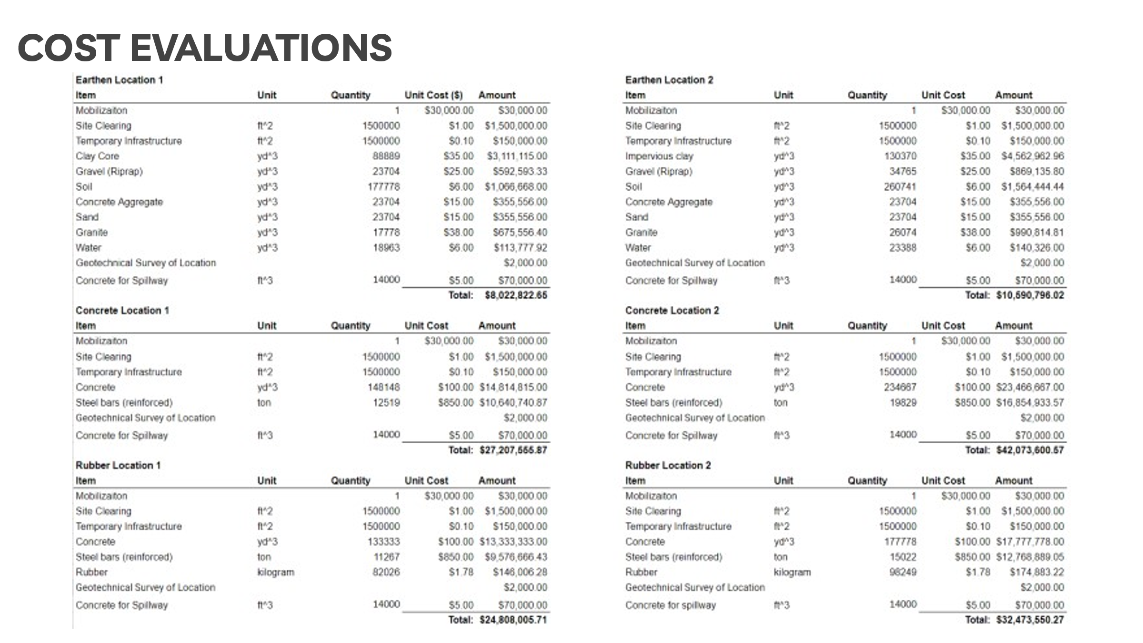
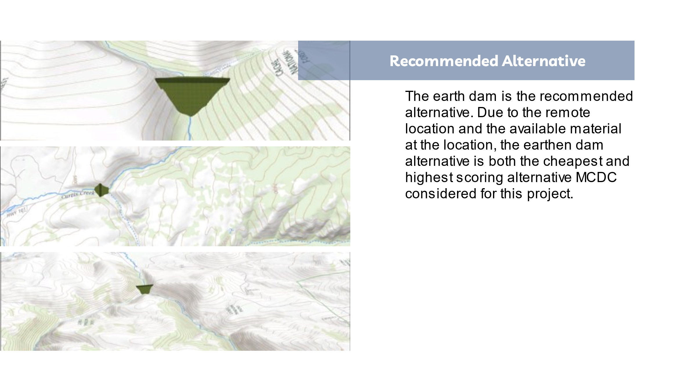
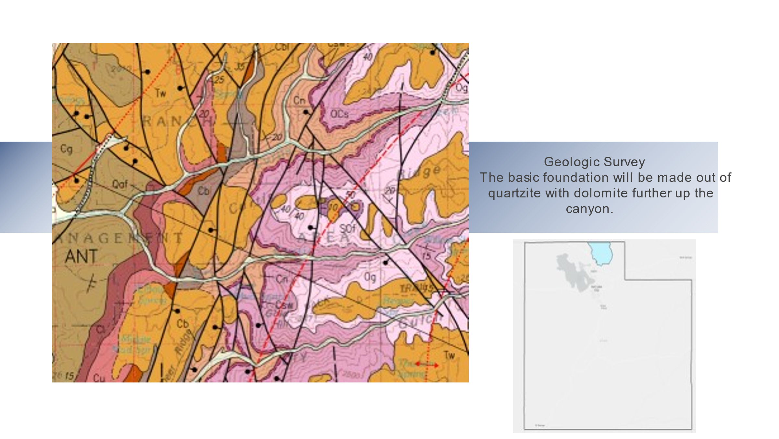
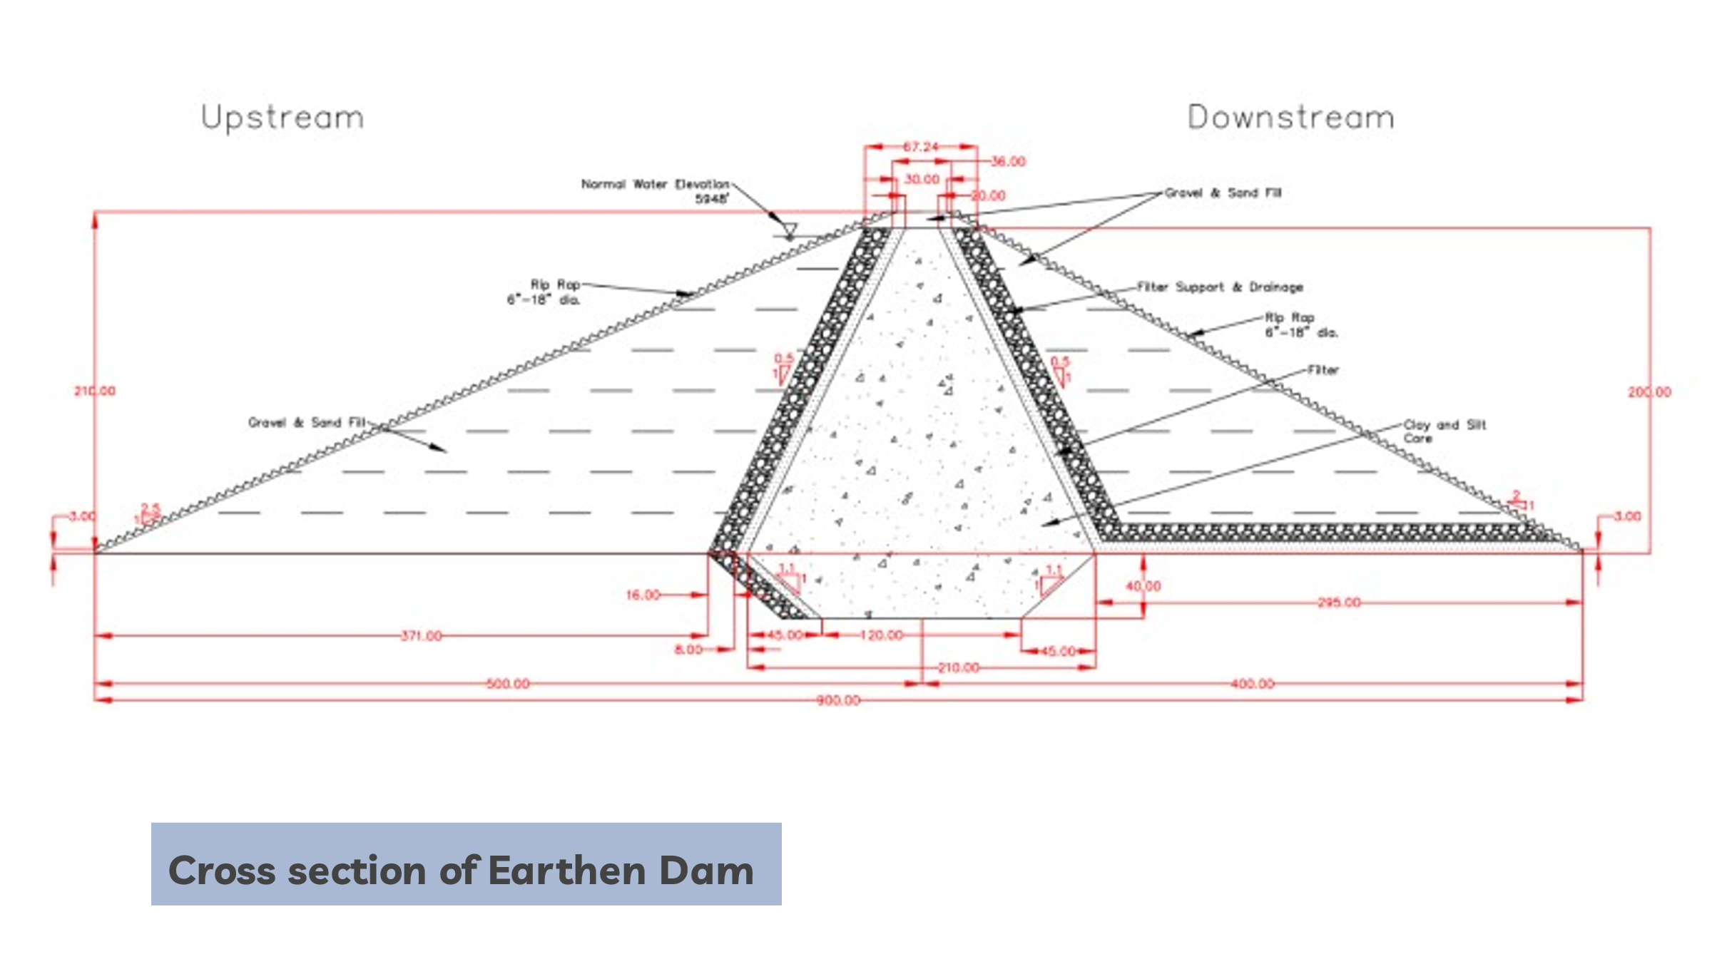
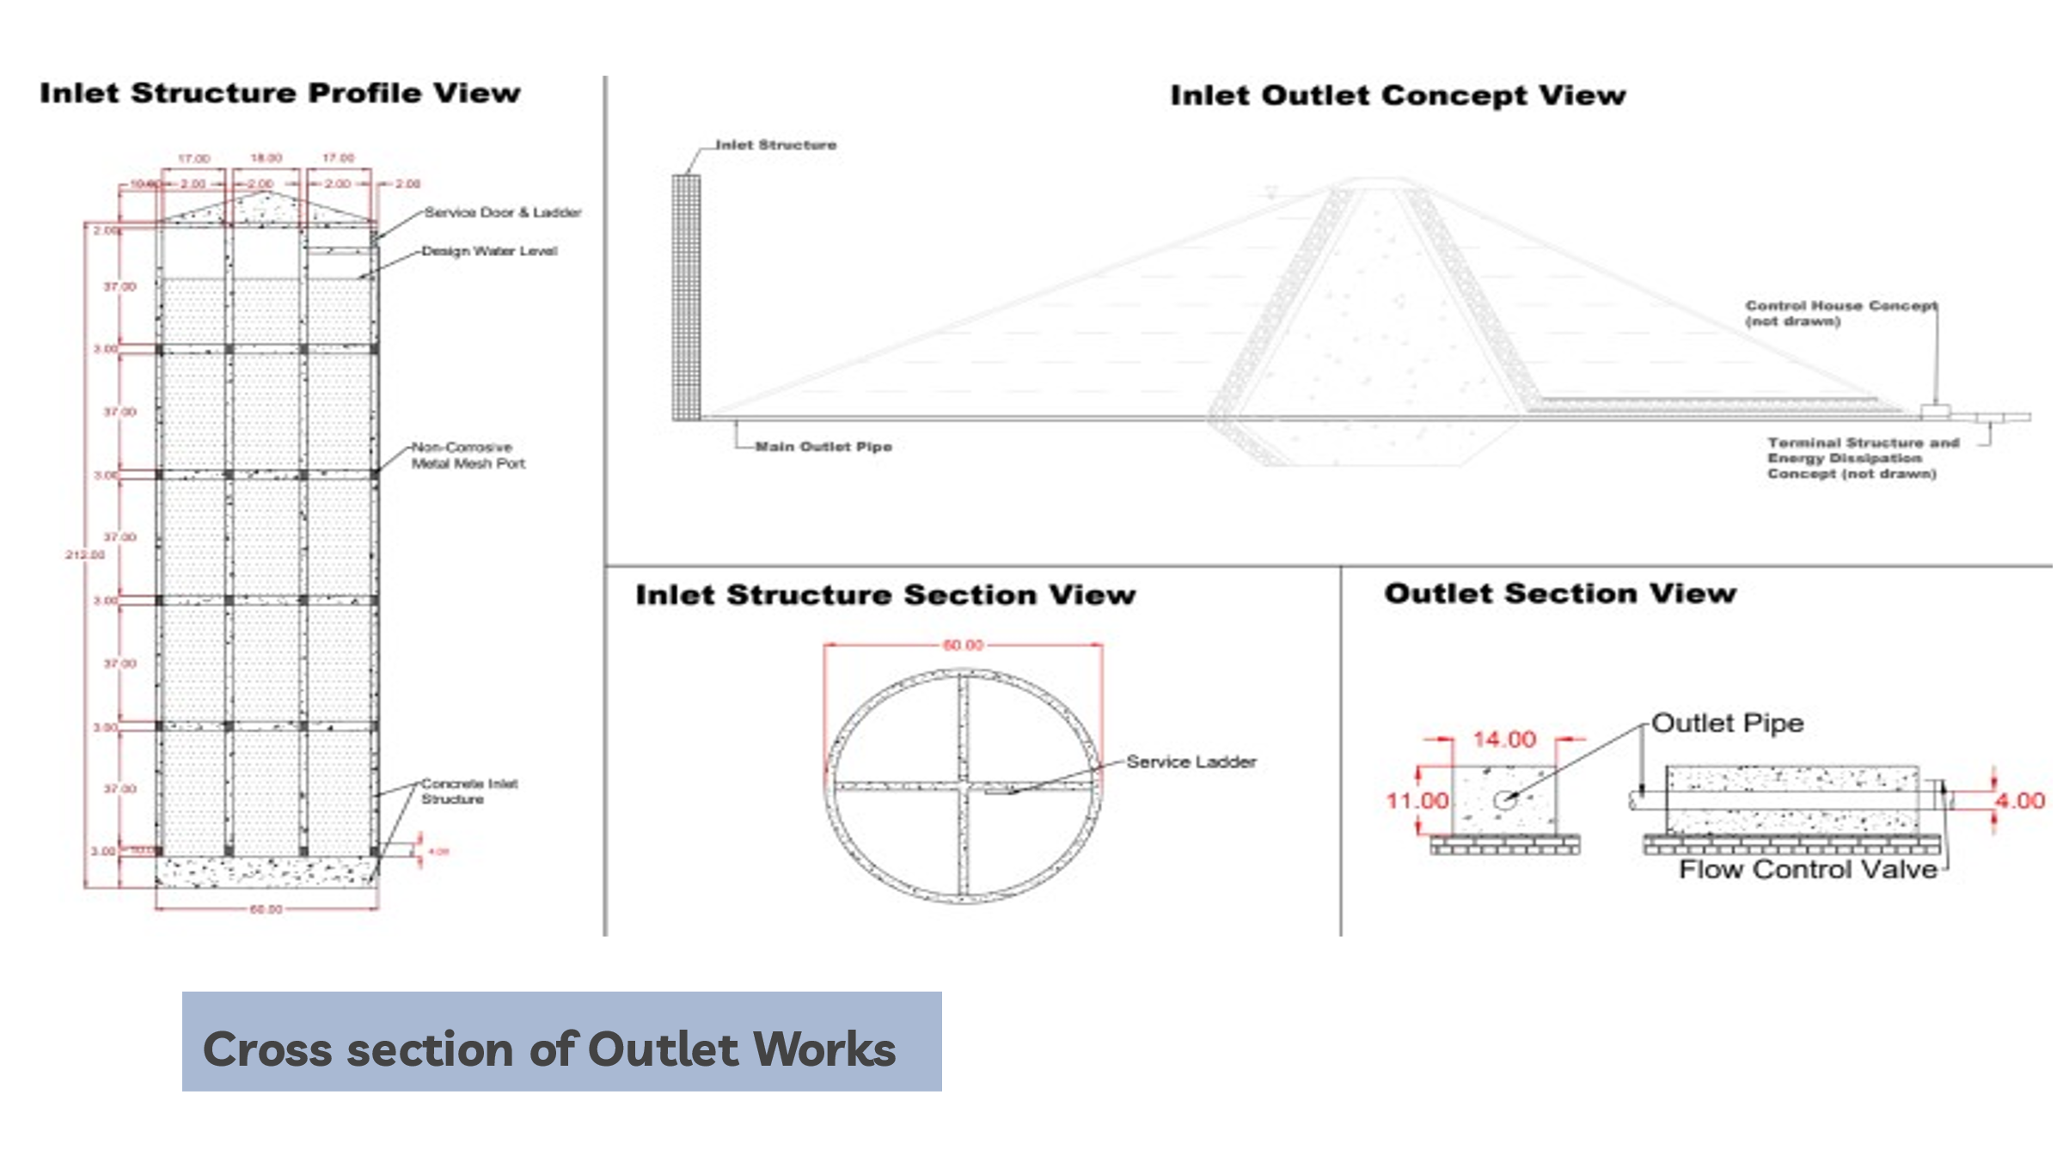

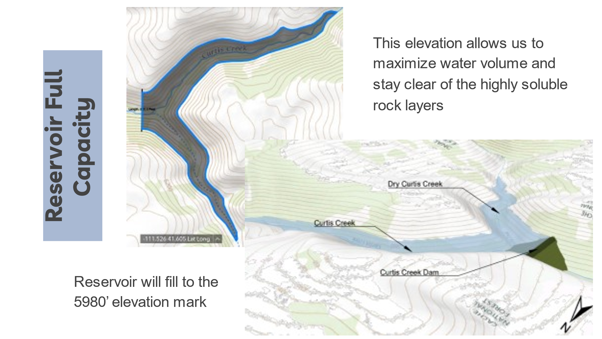
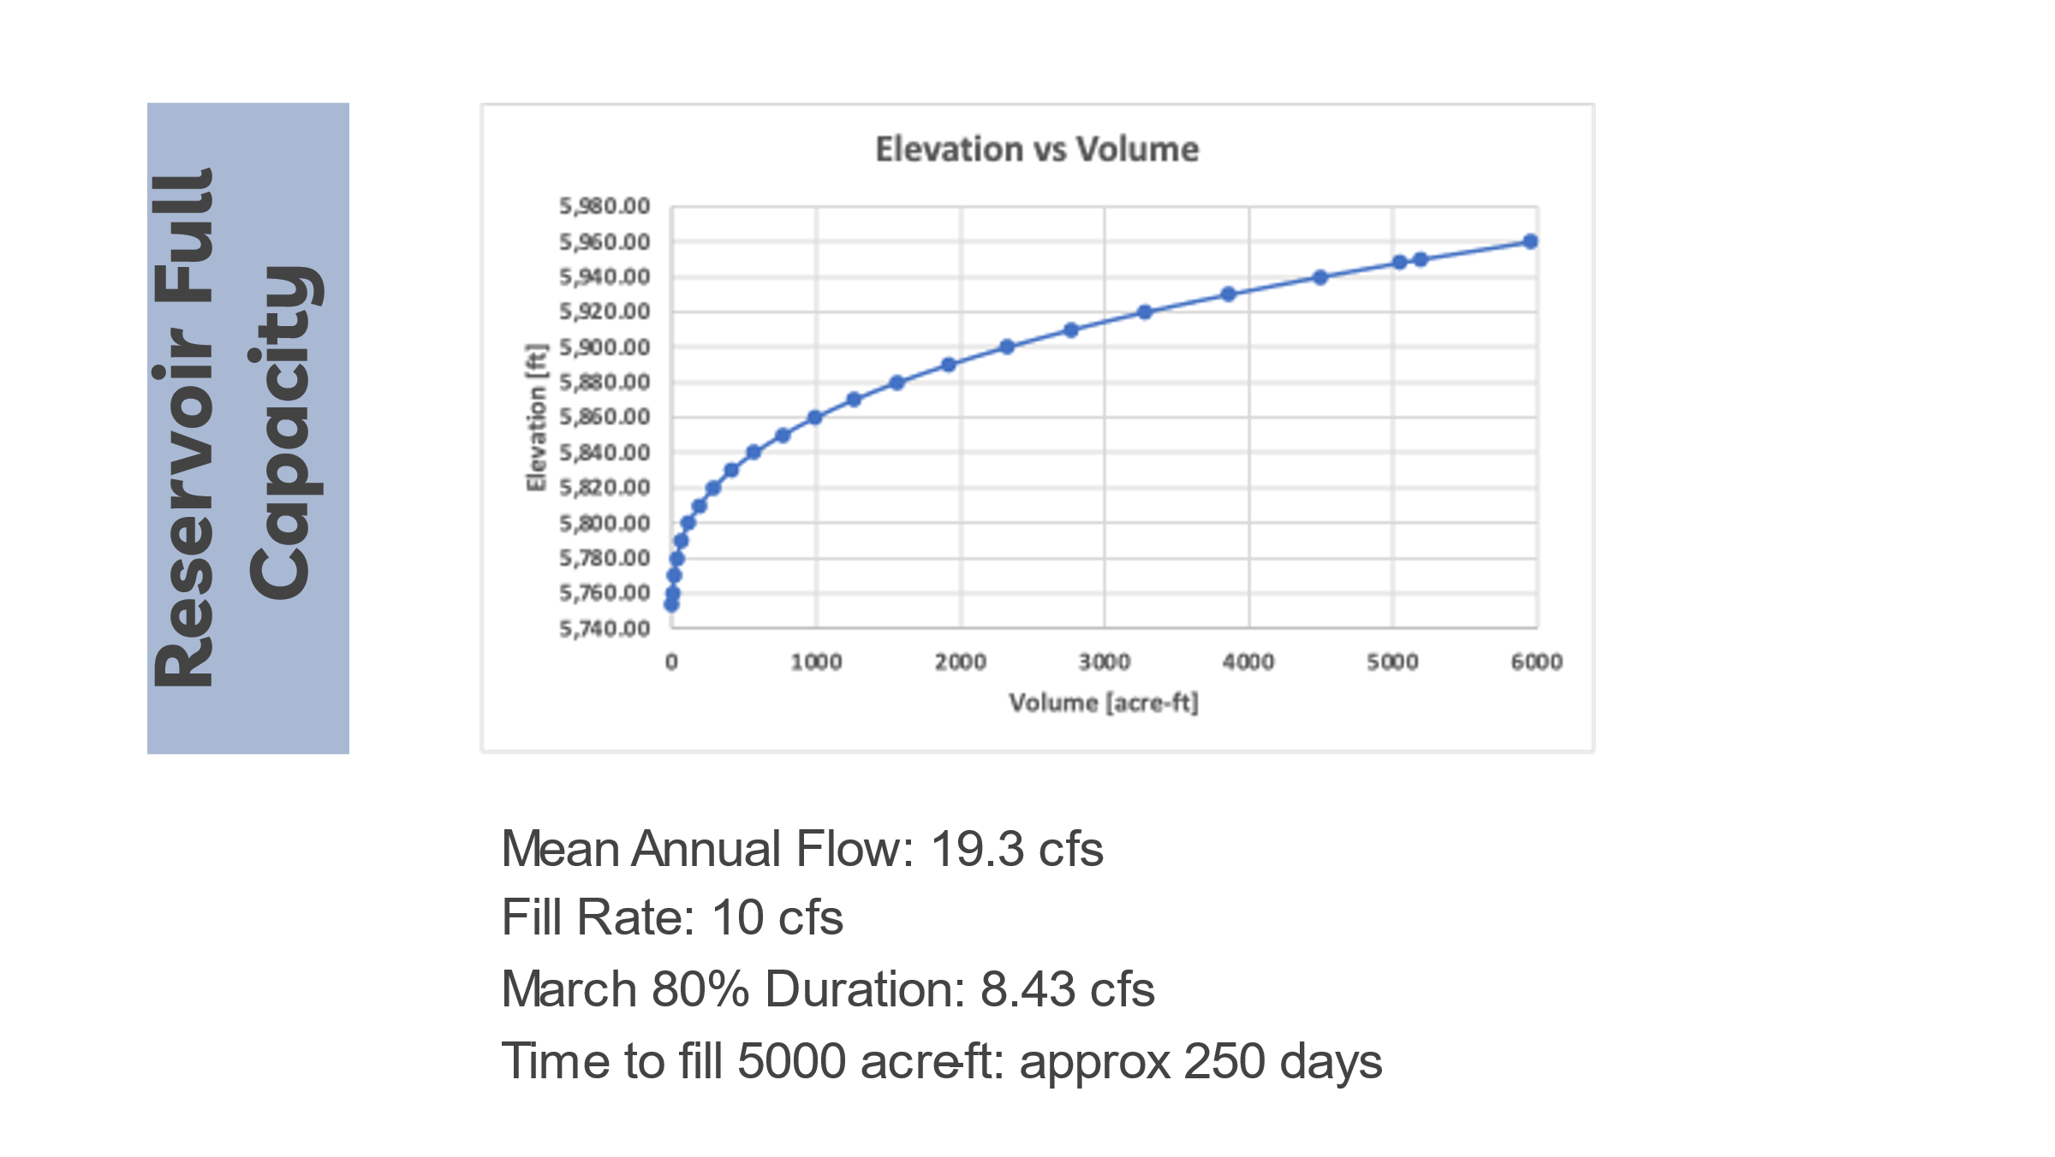

-Attachment 4-
